Dr. David W. Kistler Elementary School
Math & Literacy
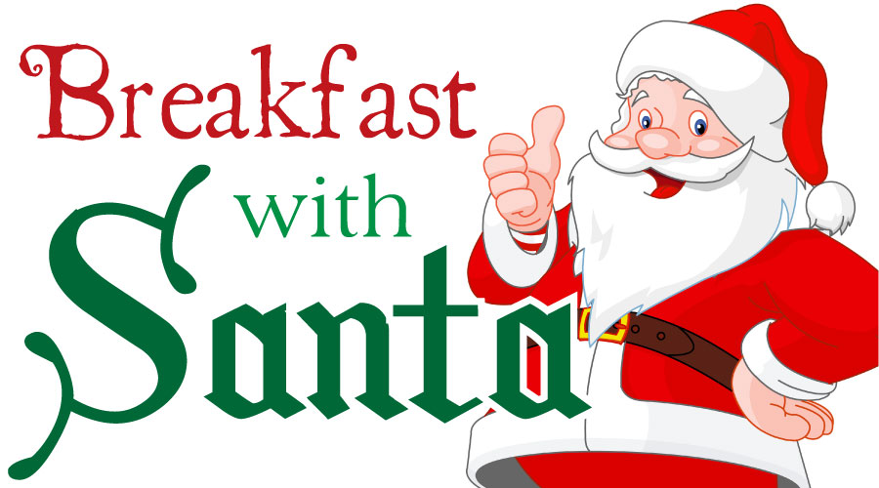
Holiday Raffle
Tickets 3 for $1.00

&

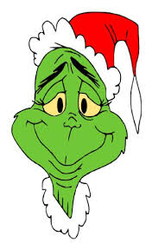
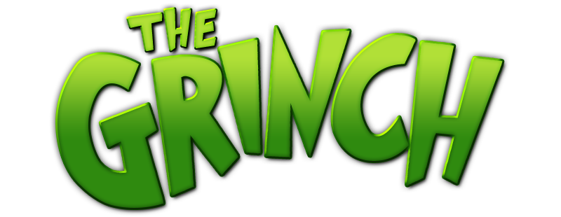
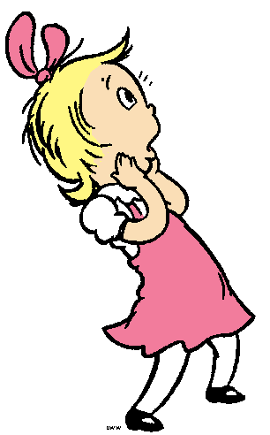

Saturday, December 10, 2016
9:00-11:00 AM

Enjoy a FREE Delicious Breakfast with Santa
Eggs, Sausage, Pancakes, Potatoes, Juice, Coffee and Milk

Story Time
Relax with the Santa and Mrs. Claus as they share classic holiday stories.
Visit with Santa & Mrs. Claus
Bring your camera and capture the moment of your child’s special visit with Santa

Whoville Events

- The Grinch’y Tree -Students will be challenged during this STEM activity to build the tallest Grinchy Tree in Whoville Prize awarded to the winner.
- Grinchy Green Food Graph – Students will participate is our Grinchy Green taste testing activity and make a prediction on the Grinch’s favorite Green Food. Results will be graphed and displayed.
- Grinchy Green Estimation Station – Guess the Grinch’s stolen Who’s stash.
- Grinch Dust- Students will make their own Grinch magic dust.
- Grinch Giving Wreath & Card Station– Students construct their own card and wreath.
- The Whoville Word Hunt – Students help the Who’s unscramble the stolen words.

Student Name/Section:___________________ Parent Name:_____________________
RETURN TO THE MAIN OFFICE
BY DECEMBER 2, 2016
______ *STUDENT(S) will be attending the breakfast.
______ ADULT(S) will be attending the breakfast.
*ALL STUDENTS MUST BE ACCOMPANIED BY PARENT/GUARDIAN

