Dr. David W. Kistler Elementary School
& Title 1 Programs Presents
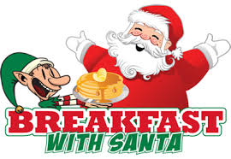
PLEASE JOIN US

Holiday Raffle
Tickets 3 for $1.00

FOR A HOLIDAY AROUND THE WORLD CELEBRATION!

Saturday, December 12, 2015
9:00-11:00 a.m.

Enjoy a FREE Delicious Breakfast with Santa
Eggs, Sausage, Pancakes, Potatoes, Juice, Coffee and Milk

Story Time with Kistler’s Elves
Relax with the Kistler Elves and Mrs. Claus as they share classic holiday stories.
Visit with Santa
Bring your camera and capture the moment of your child’s special visit with Santa

Holiday Around The World Crafts
Learn about the Holiday Around the World through reading and creating an ornament.

FREE BUS TRANSPORTATION TO & FROM KISLTER

Free Showing of Minions
F.M. Kirby Center
including Free Drink and Popcorn
BUS LEAVES Immediately Following Breakfast with Santa
Movie Sponsored by Friends of Kistler HKQ. Law Firm
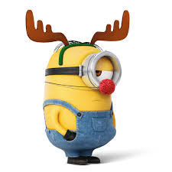

Please return the movie pass (attached separately) to reserve your seat on our bus.
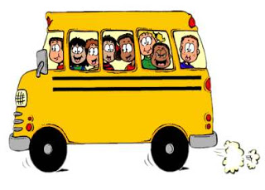

Student Name/Section:___________________ Parent Name:_____________________
RETURN TO THE MAIN OFFICE
BY DECEMBER 9, 2015
______ *STUDENT(S) will be attending the breakfast.
______ ADULT(S) will be attending the breakfast.
*ALL STUDENTS MUST BE ACCOMPANIED BY PARENT/GUARDIAN

