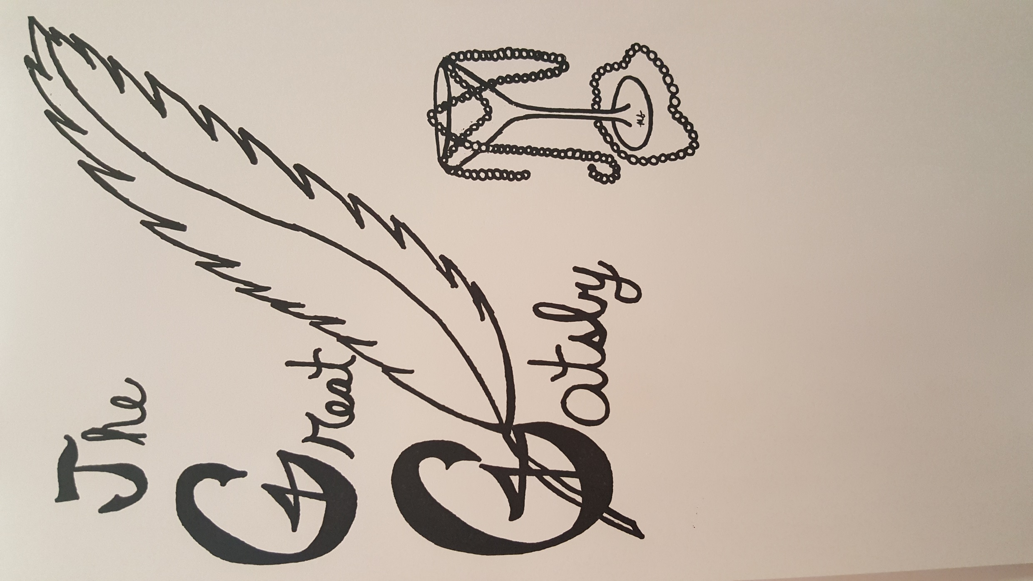

The Coughlin Players Present:

Directed By:

Alice Y. Lyons

Thursday, November 19th at 7pm

Friday, November 20th at 7pm

Saturday, November 21st at 7pm

Sunday, November 22nd at 2pm

In the Coughlin Auditorium – 80 North Washington Street, Wilkes-Barre

Tickets $7.00 Adults, $5.00 Students (High school age and under)

Based on F. Scott Fitzgerald’s novel and adapted for the stage by Simon Levy.

*The Great Gatsby* is presented by special arrangement with Dramatist Play Service, Inc., New York