**DR. DAVID W. KISTLER ELEMENTARY BUS TRIP**

## **FREE SHOWING @ F.M. KIRBY CENTER**

## 

## 



**FREE POPCORN**

**&**

**DRINK**



**SATURDAY**

**December 12, 2015**

**BUS DEPARTS KISTLER PARKING** LOT AT 11:00 A.M.

(IMMEDIATELY FOLLOWING

BREAKFAST WITH SANTA)

**BUS DEPARTS KIRBY CENTER** IMMEDIATELY AFTER THE MOVIE

**FREE CRAYOLA COLORING SET**

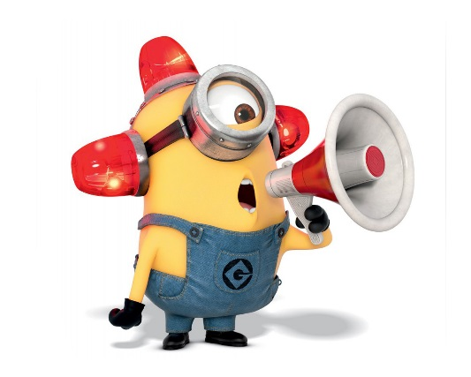

## **KISTLER BUS R.S.V.P. Form - ALL STUDENTS MUST BE ACCOMPANIED BY PARENT/GUARDIAN**

**Child’s Name__________________________________________________________ Homeroom: _______**

**Parent/Guardian ________________________________________________________________________**

**Total Guests: Adults: __________ Children: __________**

## **Phone: ____________________________________________________________**

## **\*\* RETURN TO MAIN OFFICE BY DECEMBER 9– SPACE IS LIMITED\*\***