Kistler Elementary Family
Outdoor Movie Night
Thursday- JUNE 2, 2016
Doors open at 7:15 pm. Movie plays at DUSK.
Undercover Play Area (Enter through Main Doors)

FREE ADMISSION
- All students must be accompanied by a parent or guardian
- 1 drink, meatball hoagie, chips, and popcorn will be served free of charge.

Showing: “Cloudy with a Chance of Meatballs”

- - - - - - - - - - - - - - - - -Please Detach and Return - - - - - - - - - - - - - - - - - -

KISTLER MOVIE NIGHT R.S.V.P. FORM - ALL STUDENTS MUST BE ACCOMPANIED BY PARENT/GUARDIAN
Child’s Name_________________________________________________ Homeroom: ____________
Parent/Guardian ________________________________________________________________________
Total Guests: Adults: __________ Children: __________

Phone: ____________________________________________________________

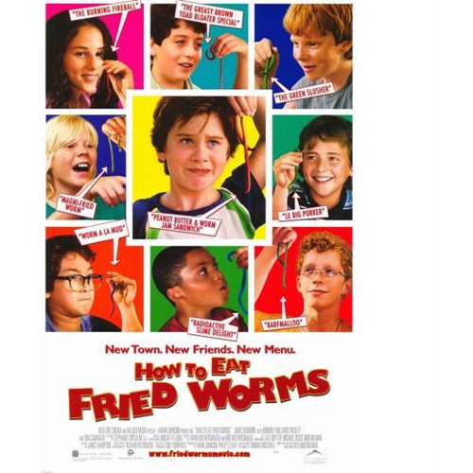
R.S.V.P. FORMS DUE WEDNESDAY, JUNE 1, 2016

