“Title 1 Family MOVIE NIGHT” 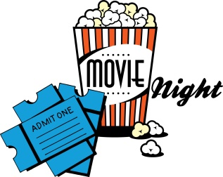 

FEATURING:

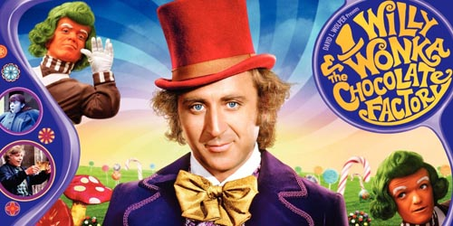 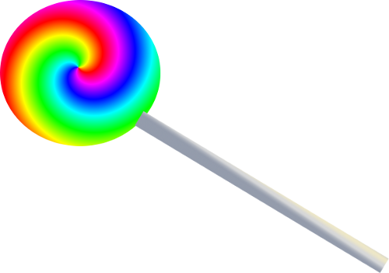

JOIN US FOR…

**Wacky Wonka Reading & Math activities

**Wonka Walking tacos, Popcorn and a drink!

**Book Giveaways and Literacy materials

HOPE TO SEE YOU THERE!!!

Thursday, September 15, 2016

Kistler Elementary School

Doors open at 7:00……………movie starts @ 7:45

Come join us for our Title 1 Back to School

Family MOVIE NIGHT!!!!!

***Families are encouraged to bring blankets & chairs

\*\*\****ALL STUDENTS MUST BE ACCOMPANIED BY AN ADULT FOR THE ENTIRE MOVIE***

Family Movie Night!

**All STUDENTS will receive a golden ticket at the door for a chance to win A Willy Wonka BOOK!!!**

